Manual Test Plan

In this test plan, we'll test all data analysis and visualization requirements are met.

Test: Data Visualization

When run the built_graph_visualization() function, a png file named graph.png should be created in the local folder.

green is actor node; blue is movie node;

the connections between each movie and actor are clearly linked by red edges

The thickness of the edge represents the wight of grossing value

The age information is represented by get_actor_age()

The total grossing value of each movie is represented by find_movie_grossed()

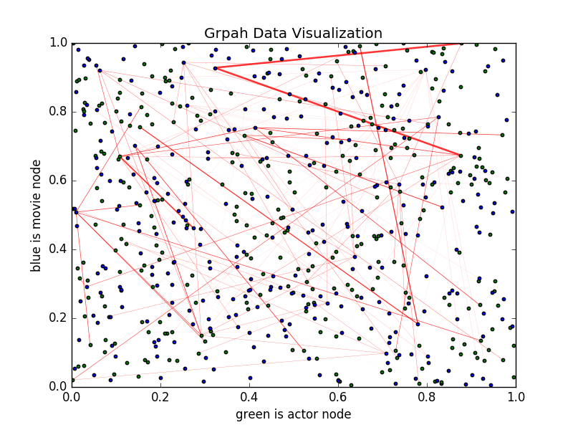

Test: movie actor conection

The find_hub_actor() function will help you find out the top k actors that have the most connections with other actors. Two actors have a connection if they have acted in the same movie together. In the console, a ordered python list will be print out to the screen.

Also, a connection.png file will be generated with built_hub_plot() which will visualize the hub frequcy.

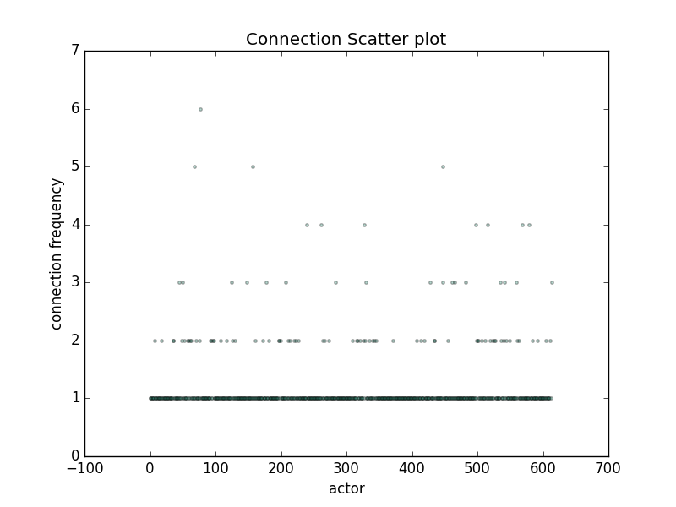

A sorted version

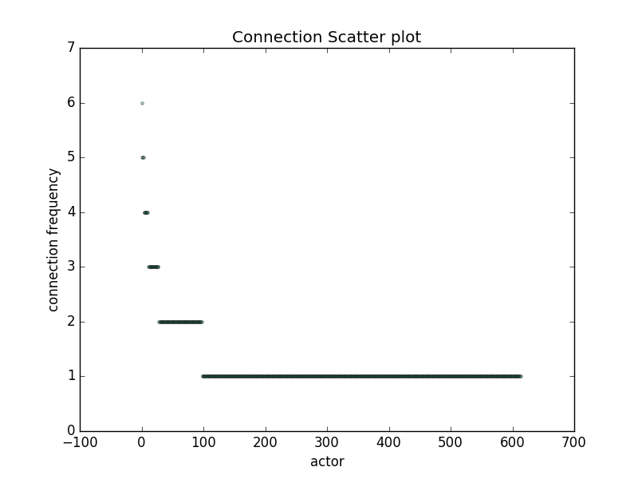

For example, there are 3 actors that have 5 conncetions.

Test: Is there an age group that generates the most amount of money? What does the correlation between age and grossing value look like?

The built_age_gross_plot() function will help you generate a correlation plot called data-analysis-age-gross-correlation.png in local folder.

X axis is the age group; y axis is the grosssing

In this JSON data records, 30--40 age group generates the most amount of money.

